1. Graph dependent variable over time (10 points)

The graph below lists the salaries, including bonuses, of Fortune 500 CEOs as a function of time.



There is a significant negative relationship between salary and time. For each 1-unit increase in time, salary decreases by approximately $4,500. Though the simple model that regresses salary on time is significant, time as a factor explains just 11 percent of the variation in the data (adjusted R-squared 0.1117), and the residuals of this simple model are not normally and independently distributed. As you can see from the graph below, this overly simple model tends to under-predict slightly a CEO’s salary.



1. Generate best-fit model (50 points)

The model I found that best fit the data was:

*salary* = *β0 + β1totcomp + β2other_comp + β3tenure + β4profits + β5assets + β6age + β7t + ε*

In this model, *totcomp* represents the total compensation CEOs earned, *other_comp* represents compensation other than salaries and bonuses, *tenure* represents the length of time the CEO has led the company, *profits* represents the company’s profits, *assets* represents the total assets of the company, *age* represents the current age of the CEO, and *t* represents time.

I created and used the instrumental variable of *other_comp* by subtracting CEOs’ salaries from their total compensation. I did this to reduce the potential collinearity that could occur from regressing CEOs’ salaries on their total compensation, which one must assume would include their salaries and bonuses, captured in the dependent variable. I also created an instrumental variable for CEO’s ages when assuming responsibility for the company by subtracting their tenure from their current age. I ultimately did not include this instrumental variable in the model because it was not significant and did not increase the amount of variance the model explained. I also created two variables that represented profits and sales as a proportion of total assets. Similarly, I created an instrumental variable that considered sales as a proportion of a company’s assets. I did not include any of the latter three variables in the model, as they did not increase the amount of variation the model explained, though all three were significant at a p-value of 0.1 or less.

With respect to dummy variables, I did not find any benefits—either in terms of the significance of coefficients or the adjusted R-squared value—to including dummy variables. I did calculate dummy variables for age—by breaking CEOs’ ages into ten-year bands—and sales—by dividing companies into low (less than $20,000,000), medium ($20,000,000-$50,000,000), and high (greater than or equal to $50,000,000) conditions. Again, neither of these sets of dummy variables improved the fit of the model in terms of significance of coefficients or increases in adjusted R-squared values.

Finally, I included time in my model, though it does change the significance level of profits from p < 0.05 to p < 0.1. This appears justified because of the increases in the adjusted R-squared value.

1. Discuss results (20 points)

The model listed above (and again below) explains 63.28 percent of the variation in the data. As I noted, none of the models I ran that included other instrumental or dummy variables improved on this adjusted R-squared value. All independent variables I included in the model are significant at the level of p < 0.1 or less.

As one would expect, both other compensation and total compensation are significant predictors of CEO salaries (p < 0.001). Interestingly, other compensation has a smaller and negative coefficient while total compensation has a larger (0.57) positive coefficient. This suggests that CEOs who receive a greater amount of income from compensation other than their salaries and bonuses tend to have lower salaries, perhaps as a mechanism for offsetting the higher amounts of compensation they might receive from stock options or other sources.

A CEO’s age (coefficient of 0.44) appears to be slightly more important than her/his tenure (coefficient of 0.04), though both are significant at the level of p < 0.05 or less. This makes intuitive sense; CEOs with longer tenures will tend to be older, though longer tenure speaks both to the increased experience and wisdom that accompanies age as well as to important markers of success such as board and shareholder approval.

Company-level factors such as profits (p < 0.1) and assets (p < 0.01) also have significant and positive coefficients, though these coefficients are small (0.03 and 0.06, respectively). I ultimately removed sales from the final model because it was not significant and it explained less of the variation in the data.

The output table below summarizes these results.

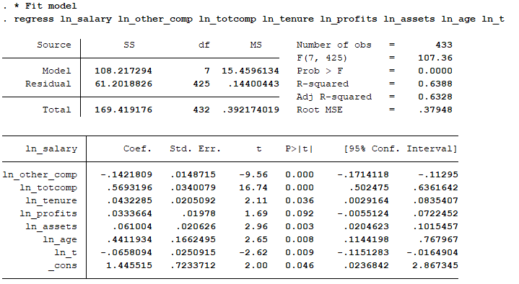

1. Discuss residuals normal and independent distribution and show graphically (20 points)

The residuals show a normal and independent distribution with a mean near 0 and a variance slightly less than 1. The residuals, which represent the difference between the actual and predicted values for a given value of y, appear to be normally distributed around the horizontal line of 0, as depicted in the graph below.



The model listed above also passes the tests we have discussed in class (omitted variables test, heteroscedasticity test), has a Durbin-Watson d-statistic of approximately 2 (2.015), and appears normally distributed based on the skewness/kurtosis tests for normality (all significant at p < 0.01) and based on kernel density estimates (see graph below).

